April James

jamesap@oregonstate.edu

**Project #1: Jumping Pasta**

For my first project, I made a very simple graphic to experiment with the features we have learned about so far, and the objects ended up looking like stiff rotini. Here are some screenshots to display my creation:

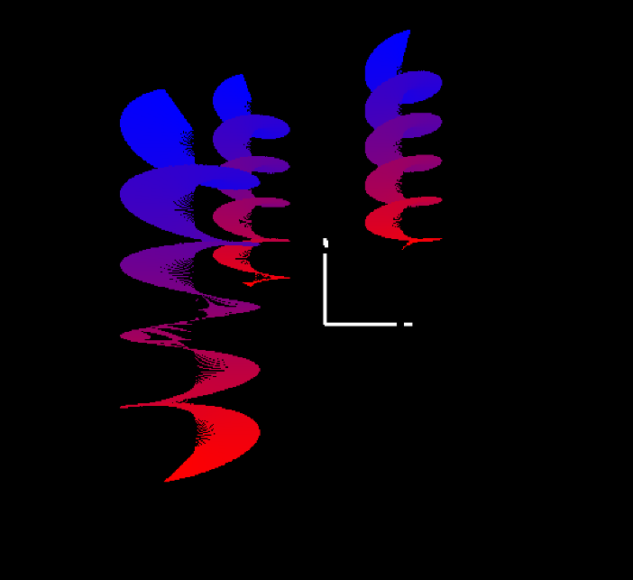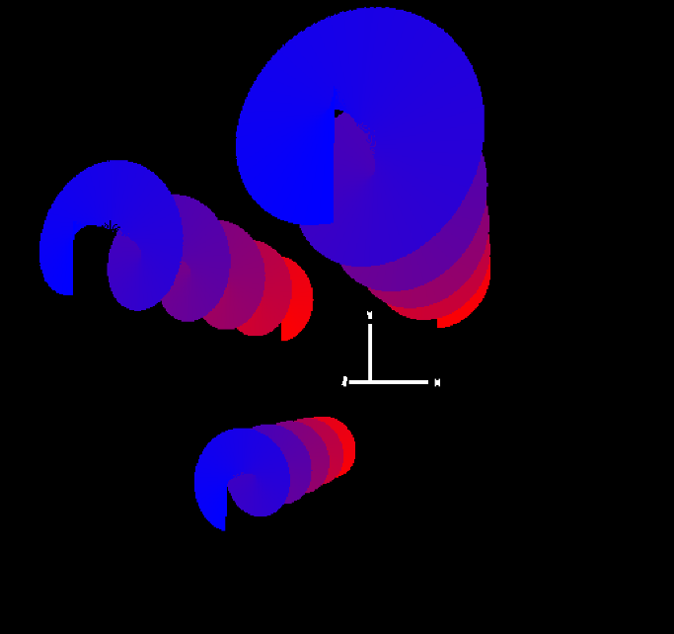

Figure : Pasta from the Side

Figure : Pasta from the Top

The coordinates for each spiral was generated from a display list loaded into memory. The topology used was GL_TRIANGLE_STRIP, spiral pattern was created by generating x/y coordinates in a circular pattern through a for-loop while linearly increasing the z coordinates. To create the color gradient, the values in glColor3f varied depending on the change in the for-loop iterator. The repetition of shapes in different locations was achieved by changing translation coordinates in a transformation command.

Here is a link to the project video: https://youtu.be/1b5pl3feWsE